Continuous Monitoring Plan for Precision Components Inc.

Part I: Business Requirements
Precision Components Inc. depends on timely, reliable data to manage production, payroll, and vendor operations. The data engineering workflow developed in Task 1 automated hourly ingestion and transformation into a centralized Redshift warehouse.
To keep that system dependable, the company needs a continuous monitoring plan that protects data accuracy, minimizes downtime, and provides transparency for every pipeline run.
The monitoring requirements are built directly from those business needs:
- Timely Data Availability: Data pipelines must complete successfully every hour to support near real-time dashboards.
- Data Accuracy and Completeness: Every dataset used in business decisions must be verified against integrity and null-value tests.
- Operational Resilience: Any failure — from ingestion delays to transformation errors — must trigger immediate alerts and automatic retries.
- Auditability: Engineers and analysts must be able to trace each task’s inputs, outputs, and transformations.
- Scalability and Reusability: Monitoring should expand as new pipelines or data sources are added without requiring major redesigns.
Together, these goals establish measurable service expectations, such as an hourly DAG-completion success rate ≥ 99 % and alert response within 15 minutes of a detected failure.

Part II: Key Monitoring Components
The continuous monitoring framework for Precision Components uses Apache Airflow as the orchestration layer with integrated AWS services. The key components include:
- Airflow DAG Monitoring: Each DAG uses built-in monitoring for task success, failure, and runtime. Retries (3 attempts, 5-minute delay) and email notifications are defined in default_args.
- Airflow UI and Logs: The web interface provides real-time and historical task logs, allowing engineers to trace errors and compare performance over time.
- Custom Operators: Custom operators—StageToRedshiftOperator, LoadFactOperator, LoadDimensionOperator, and DataQualityOperator—each include structured logging and validation logic.
- Hooks and Connectivity: PostgresHook and AWS credentials connect Airflow tasks directly to Redshift and S3, enabling live checks on data presence and load outcomes.
- CloudWatch Metrics and Alerting: AWS CloudWatch supplements Airflow by tracking anomalies in task duration, S3 object counts, and Redshift COPY latency.
- Alert Routing and Escalation: Failures automatically generate alerts to the data-engineering team via email or Slack webhooks, ensuring rapid visibility and response.
This blend of tools creates complete end-to-end visibility—from ingestion to validation—without manual monitoring.

Part III: Continuous Monitoring Plan

C1. Diagram of Monitoring Integration
Figure 3. Continuous Monitoring Plan for Precision Components Inc.
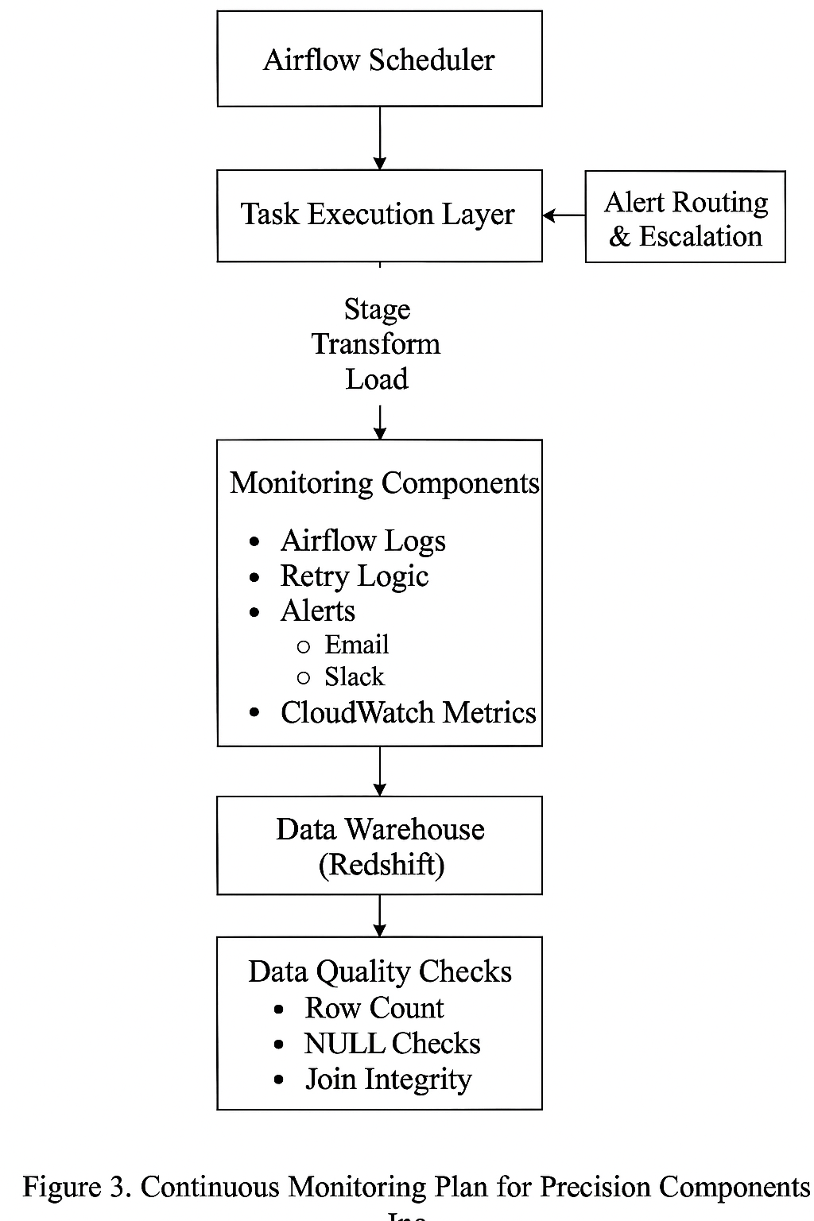
The diagram shows monitoring touchpoints through each pipeline stage. Airflow schedules and executes staging, transformation, and loading tasks. Logs, CloudWatch metrics, and alert routing ensure that issues are identified before they affect downstream analytics.

C2. Linking Monitoring to Business Requirements
Business Requirement | Monitoring Strategy
Hourly data delivery | Hourly DAG runs tracked; delays flagged in Airflow UI.
Data completeness | Row-count and null-check validations after staging and dimension loads.
Referential integrity | Fact-table joins confirm matching product and vendor IDs.
System resilience | Automatic retries and alert escalation reduce downtime.
Scalability | Parameterized operators extend monitoring to new sources without rework.
Auditability | Airflow logs and CloudWatch history record every task execution.
Monitoring is woven into every part of the pipeline rather than bolted on afterward. This alignment keeps Precision Components’ KPIs accurate and ensures operations never lose visibility.

C3. Troubleshooting and Continuity Planning
The monitoring framework also provides tools for proactive issue resolution:
- Task Failures: Detailed Airflow logs pinpoint root causes; automatic retries handle transient failures.
- Incomplete Loads: Pre-load S3 file checks verify the existence of required datasets before execution.
- Backfill Recovery: Templated DAGs allow engineers to re-run specific dates or hours without code changes.
- Real-Time Alerts: Email and Slack notifications send failure messages to on-call staff for rapid action.
- Proactive Indicators: Runtime and row-count anomalies act as early warnings of degradation, allowing intervention before SLA breach.
This combination of automated detection and manual traceability ensures business continuity even during failures.

Part IV: Summary of Business Benefits
- Higher Trust in Analytics: Every data movement step is monitored and logged, ensuring executive reports reflect validated data.
- Reduced Downtime and Faster Recovery: Automatic retries and alert routing cut manual intervention time by as much as 40 %.
- Scalable and Maintainable Framework: The monitoring structure expands naturally as new datasets or pipelines are added to the platform.
The result is a resilient, transparent system that protects data quality and keeps the business running smoothly around the clock.

References
Apache Software Foundation. (n.d.). Apache Airflow documentation. https://airflow.apache.org/docs/
Amazon Web Services. (n.d.). Amazon Redshift documentation. https://docs.aws.amazon.com/redshift/
Amazon Web Services. (n.d.). Amazon S3 documentation. https://docs.aws.amazon.com/s3/
Udacity. (n.d.). Data pipelines with Airflow [Course materials]. https://www.udacity.com/course/data-engineer-nanodegree--nd027
Google. (n.d.). Site reliability engineering: Monitoring distributed systems. https://sre.google/books/

